Orange Blossom Miniature Horse Club Membership Application
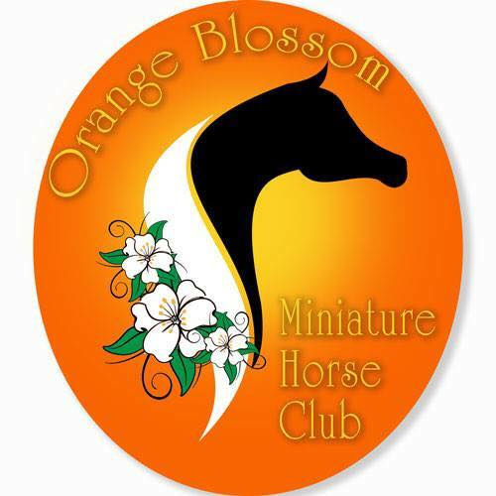
Please make checks payable to OBMHC and mail your membership application and payment to: Danielle Menzies, 4665 Arborfield Rd, Sarasota, FL 34235

Individual Membership
$30

Family Membership
$45

Member Name:__________________________________________________________________________ Name(s) of Spouse or other family members living in the same household:
Spouse: _________________________________________________________ ________________ _____
Child:______________________________________________________________ _DOB:_________________
Child: ______________________________________________________________ _DOB:_________________
Child: _____________________________________________________ ___ _ DOB:__________ ______
Farm or Ranch Name:______________________________________________________________________
Mailing Address:___________________________________________________________________________
City:_________________________________________State:________________Zip Code:_______________
Email Address:_____________________________________________________________________________
Website Address:___________________________________________________________________________
Telephone:______________________________________FAX:______________________________________

